**Final Project**

1. Name
   * 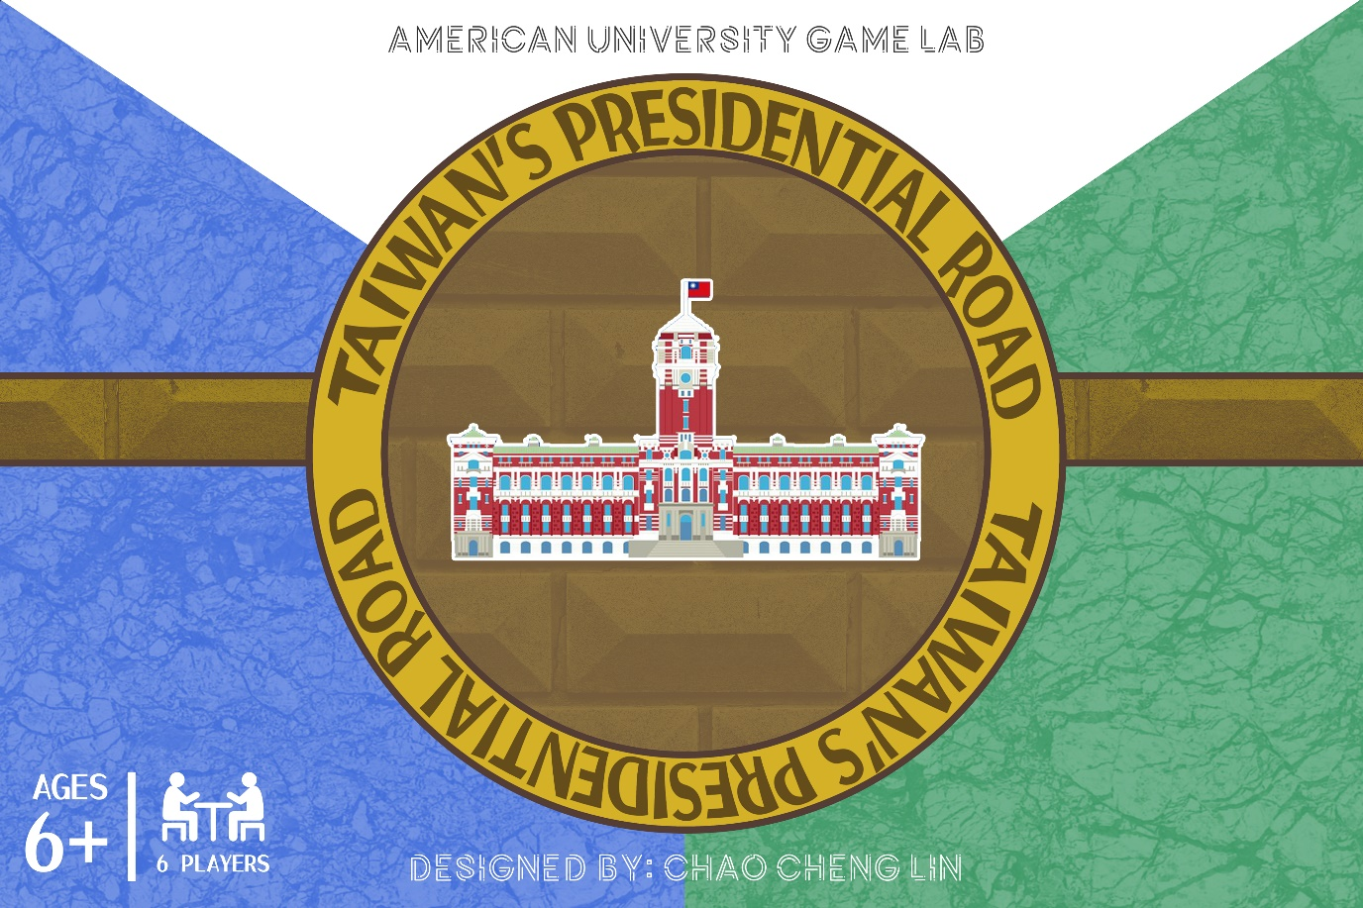**Taiwan’s presidential road**
2. Gameplay description

* core mechanic: **Role Playing, social, and Campaign / Battle Card Driven game**

Play as a presidential candidate, use the strategic cards by the events and cooperate or betray the other candidates to win the election.

1. Input

Strategic cards with RFID tag, and tablet will receive the data from the RFID reader.

1. Visual style

Character style: comic style form Taiwanese artist

Card style: comic style by myself



1. Audio style
   * Taiwanese songs(pops, old school)
2. Interface sketches

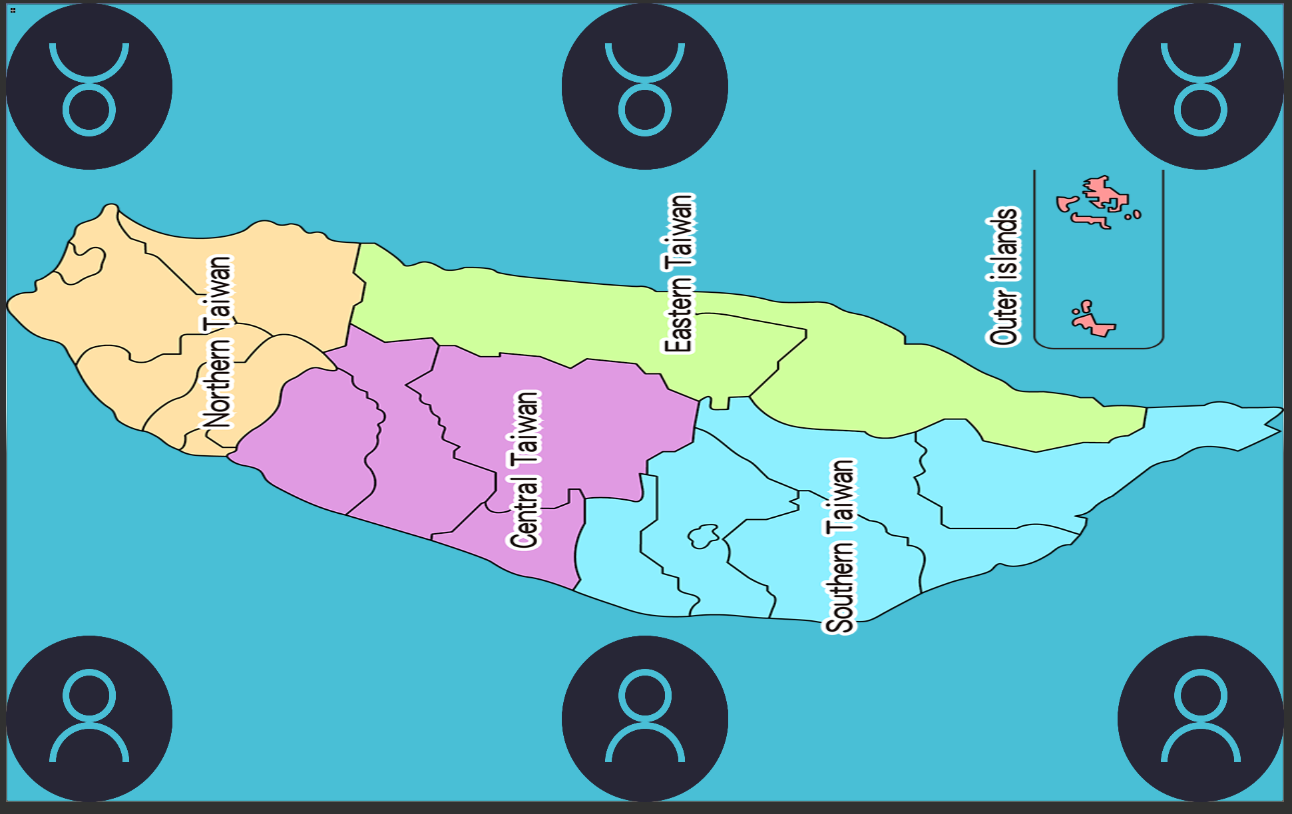

1. Story/theme description
   * Players are presidential candidates. And players need to use some strategic cards to increase your supporters or change voting rate.
   * Players will see their supporters’ detail and voting rate after two rounds later.

(Ex: Players will see voting detail of first round when they finish the third round.)

* + Players will debate to the other candidate after the sixth round.

1. the “low-bar “of you will create (this should still be a “complete game”)
   * Win/Lose status
   * Boardgame version
   * Without images/music
2. a target that you expect to get done
   * RFID tags of character card, and strategic cards.
   * Debate topic & Event detail
   * Characters art
3. a desired high-bar if things go exceptionally well.
   * With images/music
   * Combine the real election event
   * Some random event

**Character** :

Mr Ko: Using campaign cards will get bonus young supporters

Ms Tsai: Using feat youtuber cards will get bonus young supporters

Mr Ma: if your supporter higher than your opponent when you are using the traditional poll cards, you will get bonus old supporters.

Mr Wang: Using Club of Senior Citizens cards will get bonus old supporters.

Mr. Lin: if your supporter higher than your opponent when you are using the Onlin poll cards, you will get bonus young supporters.

Mr. Wu: Using Political show smear tactics cards dice number only have 3 4 5 6

Mr. Han: Using campaign cards will get bonus old supporters

Mr Lai: Using online smear tactics cards dice number only have 3 4 5 6

Mr Chen: Using bribe card will get bonus supporters.

**Strategic:**

Traditional Campaign

Flyer

Digital Campaign

{Increase supporters}

Bribe

{Get the supporters from the top candidate}

Feat Youtuber

Club of Senior Citizens

{Increase voting rate}

Long distance to polling location

geriatric disease

{Decrease voting rate}

online poll

traditional poll

{Choose a candidate. And if your supporter lower than the candidate, you will get the supporters form the candidate.}